**Assignment 4 –** Spending Management

In this app the user can manage how much money they have added to their balance or how much they have spent. The user opens the app and their *current balance* is shown in the top right corner. The user can then add money or subtract money from their *current balance*.

Case 1: If the user wants to add money to their current balance, they first input the date in the *date* text box. Next, they will input the amount of money into the *amount* text box. Then, they will input what the money is for into the *activity* text box. Finally, they will click the *plus* (+) button and the app will add the amount to the *current balance*. The app will also write a line in the *history* text box containing the *date*, *amount* and *activity*.

Step 1: User inputs data into *date*, *amount*, and *activity*.

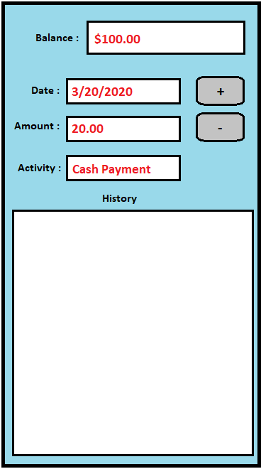

Step 2: User Clicks the *plus* (+) button, and the *amount* is added to *current balance*.

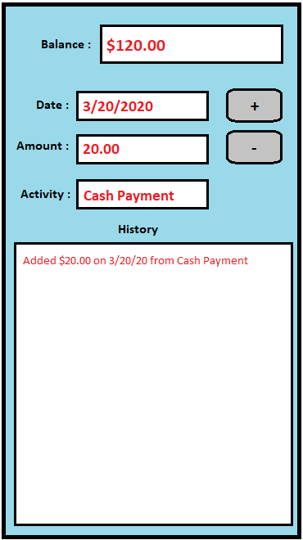

Case 2: If the user wants to subtract money from their current balance, they first input the date in the *date* text box. Next, they will input the amount of money into the *amount* text box. Then, they will input what the money was spent on into the *activity* text box. Finally, they will click the *minus* (-) button and the app will subtract the amount from the *current balance*. The app will also write a line in the *history* text box containing the *date*, *amount* and *activity*.

Step 1: User inputs data into *date*, *amount*, and *activity*.

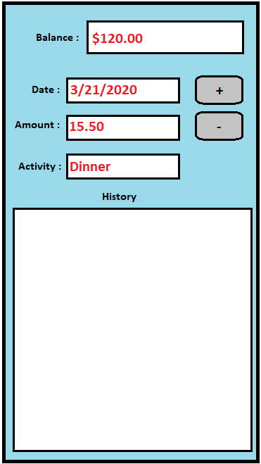

Step 2: User Clicks the *minus* (-) button, and the *amount* is subtracted from the

*current balance.*

